Title: **Tank 1 Process Control** Project: 1

Course: Intro to Automation Unit: Introduction to PLC CLO: 4

Name ______________________________ Grade ________ Date ________________

**Objectives**

1. Student shall design a PLC program to automate a process tank.
2. Student shall create a hand drawn design of the PLC wiring for the program.
3. Student shall render a computer aided schematic of the same design.

**Assessment**

Students shall demonstrate a comprehension of the objectives listed above by scoring a minimum of 75% on this Project. Grading shall be based on the Introduction to PLC rubric.

**Controls**

* Hot Water Supply Control
* Tank Level Control
* Water Temperature Control
* Tank Vent Control

Common Tank Controls

**Devices**

|  |  |  |  |
| --- | --- | --- | --- |
| Inputs | | | |
| *Adrs* | *Device* | *Description* | *Symbol* |
| I/0 | Mushroom-head Pushbutton | Emergency Stop | TK1_ESTOP |
| I/5 | Two-position Selector Switch | Mode: Off, Automatic | TK1_MD |
| Outputs | | | |
|  | *Device* | *Description* | *Symbol* |
| O/0 | Green Pilot Light | Tank Normal Operation | TK1_OK |
| O/1 | Yellow Pilot Light | Tank 1 Low Level | TK1_EMPTY |
| O/2 | Red Pilot Light | Tank 1 Off/Alarm Status | TK1_STAT |
| O/3 | Blue Pilot Light | Tank 1 High Level | TK1_FULL |

**Instructions**

Use the components listed above to either control the entire tank or to communicate the status of the process tank. The emergency stop, if pressed, shall halt all process tank activity and place all final control elements in their *safe state*. The mode selector switch when in automatic shall control the process tank as described in the units below. When the selector switch is in the off mode, the tank shall cease all automatic operation. If the process tank has no alarms or interlocks as describe below and is in the automatic mode, the green light shall illuminate. If the tank has a low level as indicated by a level switch, the yellow light shall illuminate. If the tank experiences a high-level condition, the blue light shall illuminate. The red light shall be on if either the process tank has been placed in the off mode or shall flash if an alarm or interlock has occurred. The process tank RSLogix template shall include both a simulation subroutine for the tank and an error flash sub-routine that can be used to flash the red light in the event of an error. See the table below for error code numbers.

|  |  |  |  |
| --- | --- | --- | --- |
| 1 | High Pressure Alarm | 6 |  |
| 2 | High Temperature Alarm | 7 |  |
| 3 | No Flow Alarm | 8 |  |
| 4 | Motor Overload Alarm | 9 |  |
| 5 |  | 10 | Emergency Stop |

Hot Water Supply Control

**Devices**

|  |  |  |  |
| --- | --- | --- | --- |
| Inputs | | | |
| *Adrs* | *Device* | *Description* | *Symbol* |
| I/1 | Motor Starter Contacts (53-54) | Pump Motor Starter Status | PC1_STAT |
| I/4 | Three-position Selector Switch (B) | Pump Mode: Auto | PC1_AUTO |
| I/8 | Normally Open Pushbutton (PB3) | Interlock Reset | PC1_RST |
| I/9 | Motor Starter Overload Contacts (NO) | Pump Overload Indication | PC1_OL |
| I/10 | Float Switch (M-BLU-40-W) | Low Level Indication | LO_LVL1 |
| I/11 | Flow Switch | Flow Indication | FLOW1 |
| Outputs | | | |
| *Adrs* | *Device* | *Description* | *Symbol* |
| O:0/4 | 3-Phase Motor Starter | Pump Motor Starter | PC1 |
| O:0/6 | Green Pilot Light | Pump is Running | PMP1_ON |
| O:0/7 | Red Pilot Light | Pump is Off (Flash Overload) | PMP1_OFF |

**Instructions**

Design an automatic control scheme that shall control the supply of hot water to a plant production facility utilizing the devices listed above. The circuit can be in automatic mode or off using the process tank’s two position *mode* selector switch. The entire control scheme shall be protected by the process tank’s emergency stop. Additionally, the three-position selector switch shall be used as a hand-off-auto switch for this pump. When the three-position switch is in the B position, the circuit shall be in pump auto mode. If the switch is in off or hand, the PLC shall not control the pump. Using the input from the low-level float switch, control a pump at the bottom of the tank to supply the hot water. If there is water that is at least 100˚F present in the tank, the pump shall run providing hot water throughout the plant. Study the datasheet below for the specific level switch listed above before embarking on the design. The pump shall be protected through an *interlock* that tests to ensure water is flowing after the pump has been started. If the pump has been running for five seconds without an indication of flow through the flow switch listed above, the pump shall be stopped. It shall be necessary to *reset* the interlock condition with the pushbutton listed above before the pump may be commanded to start again. Whenever the pump is running, the green light shall illuminate, and the red light shall be off. When the motor is not running, the green light shall be off, and the red light shall illuminate. If an interlock occurs, the red light shall flash slowly. If an overload occurs, the red light shall flash quickly.

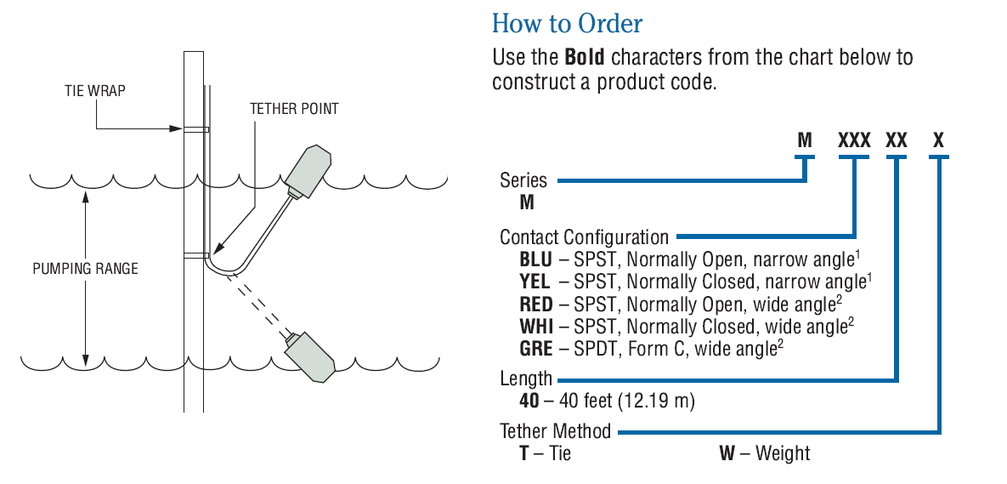

Tank Level Control

**Devices**

|  |  |  |  |
| --- | --- | --- | --- |
| Inputs | | | |
| *Adrs* | *Device* | *Description* | *Symbol* |
| I/2 | Eleven-Pin Relay Contacts (1-3) | Level Valve 1 Status | VLC1_STAT |
| I/6 | Normally Closed Pushbutton (PB1) | Close Valve | VLC1_CLOSE |
| I/7 | Normally Open Pushbutton (PB2) | Open Valve | VLC1_OPEN |
| I/10 | Float Switch (M-BLU-40-W) | Low Level Indication | LO_LVL1 |
| I/12 | Float Switch (M-YEL-40-W) | High Level Indication | HI_LVL1 |
| Outputs | | | |
| *Adrs* | *Device* | *Description* | *Symbol* |
| O/5 | Eleven-Pin Relay | Valve Control Relay | VLC1 |
| O/8 | Green Pilot Light | Water Valve Opened | VLV1_OPND |
| O/9 | Red Pilot Light | Water Valve Closed | VLV1_CLSD |

**Instructions**

The tank level control shall consist of the devices listed above. The process tank’s emergency stop shall protect the circuit. The circuit shall run *automatically* when the process tank’s mode switch is in the AUTO position. The level in the tank shall be controlled by two float switches when the process tank is in automatic mode. When a low-level is detected through the switch listed above, the tank inlet valve shall open and fill the tank. The valve shall remain open filling the tank until the high-level switch detects that the tank is full. Additionally, two pushbuttons shall be utilized to also control filling of the tank. If the normally open pushbutton is pressed while the process tank is in off or auto, filling shall commence. Study the float switch specification found below before composing the design. If at any time the process tank is taken out of automatic mode, the fill valve shall close. If the valve is open, the green light shall illuminate. If the valve is closed, the red light shall illuminate. If a high-level occurs, the process tank’s blue light shall illuminate.



Water Temperature Control

**Devices**

|  |  |  |  |
| --- | --- | --- | --- |
| Inputs | | | |
| *Adrs* | *Device* | *Description* | *Symbol* |
| I/13 | Eight-Pin Relay Contacts (1-3) | Steam Valve 1 Status | SC1_STAT |
| I/14 | Temperature Switch (NC) | High Temperature Interlock | HI_TMP1 |
| I/16 | Pressure Switch (NC) | Tank 1 High Pressure | HI_PRS1 |
| F8:0 | Temperature Transmitter | Tank Temperature Indication | TT1 |
| F8:1 | Level Transmitter | Water Level Indication | LT1 |
| Outputs | | | |
| *Adrs* | *Device* | *Description* | *Symbol* |
| O/10 | Eight-Pin Relay | Steam Control Relay | SC1 |
| O/11 | Green Pilot Light | Steam Valve Open | STM1_OPND |
| O/12 | Red Pilot Light | Steam Valve Closed | STM1_CLSD |

**Instructions**

Design a deadband control scheme that shall control the temperature of water inside the process tank. The hot water shall be utilized throughout the plant production facility. If the process tank is in automatic mode and the tank has enough level, a steam valve shall control the temperature of the water through a steam coil inside the tank. The tubing coil will circulate steam inside the tank transferring heat from the steam into the water inside the tank. To control the temperature inside the tank, the water level in the tank must be greater than 30% as indicated through the level transmitter. The temperature of the water in the tank is registered by the temperature transmitter listed above. If the tank temperature is less than 150˚F, the steam valve shall open. The steam valve shall remain open until the water temperature reaches 200˚F. When the temperature reaches or exceeds 200˚F, the steam valve shall close. The steam valve shall remain closed until the temperature falls to 150˚F again, then it shall re-open. If at any time a high temperature condition is detected via the temperature switch listed above, the steam valve shall be closed. Additionally, if at any time a high pressure condition occurs as indicated by the pressure switch listed above, the steam valve shall be closed. Finally, if an emergency stop condition occurs or the process tank is taken out of automatic mode, the steam valve shall close as well.

Tank Vent Control

**Devices**

|  |  |  |  |
| --- | --- | --- | --- |
| Inputs | | | |
| *Adrs* | *Device* | *Description* | *Symbol* |
| I/1 | Motor Starter Contacts (53-54) | Pump Motor Starter Status | PC1_STAT |
| I/2 | Eleven-Pin Relay Contacts (1-3) | Level Valve 1 Status | VLC1_STAT |
| I/15 | Eight-Pin Relay Contacts (1-3) | Vent Valve 1 Status | VTC1_STAT |
| I/16 | Pressure Switch (NC) | Tank 1 High Pressure | HI_PRS1 |
| Outputs | | | |
| *Adrs* | *Device* | *Description* | *Symbol* |
| O/13 | Eight-pin Control Relay | Vent Valve Control Relay | VTC1 |
| O/14 | Green Pilot Light | Vent is Open | VNT1_OPND |
| O/15 | Red Pilot Light | Vent is Closed | VNT1_CLSD |

**Instructions**

The process tank utilizes a vent valve to ensure that an excess of pressure inside the tank does not cause an unsafe condition. The vent valve shall be controlled using the devices listed above. If the process tank is being filled, but the pump is not running removing water from the tank, an excess of pressure will build up since the air inside the tank has no place to go. If this condition occurs, the vent valve shall be opened. If water is being removed from the tank but the tank is not being filled, this will cause a vacuum to occur inside that tank. If this condition occurs, the vent valve shall be opened. If the tank is being filled and the pump is removing hot water from the tank, the vent valve shall be closed. If a high pressure condition occurs as indicated by the pressure switch listed above, the vent valve shall open. The green light shall indicate that the valve is open, and the red light shall indicate that the vent valve is closed. If a high pressure condition occurs, the red light shall flash.

This page intentionally almost blank